E-Read Texas website text
September 2024

About this document
This document contains suggested text to use on your library website. Feel free to make edits as you feel appropriate. TSLAC recommends linking the Boundless logo to your Boundless URL. Locate your onboarding email from Baker & Taylor to find your Boundless URL.

Links to Logo image files
E-Read Texas
Boundless

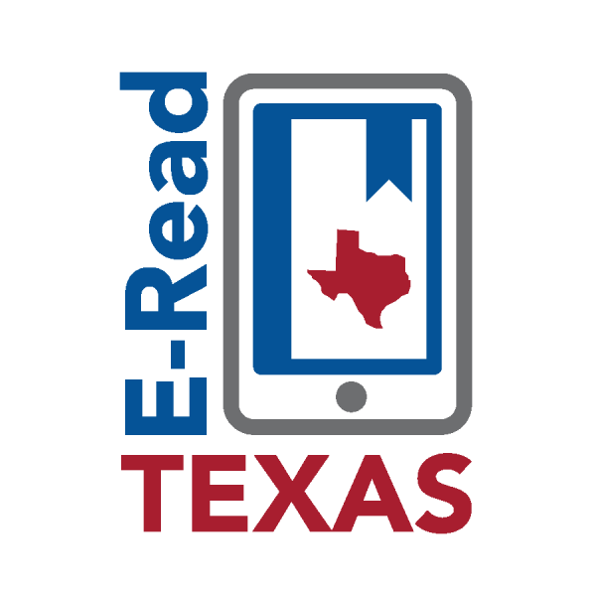
E-Read Texas provides 20,000 e-books and audiobooks to eligible public libraries in Texas. The collection contains popular adult fiction and non-fiction, as well as some young adult crossover materials. You’ll find newly published titles from well-known authors, as well as classics and independent fiction. There’s also a great selection of nonfiction titles to help you learn new things, such as languages, arts and crafts, gardening, or business skills.


Titles can be accessed through the Boundless app, which is available for Apple, Android, and Kindle Fire devices. Please contact us if you have any questions about using Boundless.

